PROJECT:01
TITLE : AI BLOGNEST API - GENERATE HIGH-QUALITY BLOG CONTENT USING AI

AI BlogNest API Introduction:
In today's digital world, blogs are widely used to share knowledge, opinions, tutorials, news, and experiences. However, creating quality blog content manually requires considerable time and effort.
AI BlogNest combines a traditional blog management system with Artificial Intelligence. The system allows users to manage their blogs and provides AI-based features such as:
- AI blog generation

- Blog summarization

- User authentication

- Blog creation and editing

- Blog viewing

- Blog deletion

- Secure API access

The project uses Node.js, Express.js, MongoDB, JWT authentication, and Google Gemini AI.

AI BlogNest API Description:
AI BlogNest is a full-stack web application developed using the MERN-oriented technology approach, with Node.js and Express.js used for the backend and MongoDB used as the database.

Blog Management
Users can:

- Register an account

- Login securely

- Create blogs

- View blogs

- Update blogs

- Delete blogs

AI Features:
The application uses Gemini AI to:

- Generate complete blog content from a topic

- Summarize lengthy blog content

- Assist users in creating content quickly

The backend provides REST APIs that can be tested using Thunder Client or similar API testing tools.

Objectives:
The main objectives of AI BlogNest are:

- To develop an AI-powered blogging platform.

- To provide secure user registration and login.

- To implement JWT-based authentication.

- To allow users to create and manage blog posts.

- To provide AI-based blog generation.

Problem Statement:
Traditional blogging platforms mainly depend on users to manually create and edit their content. This creates several problems:
- Writing content takes more time.

- Users may find it difficult to generate ideas.

- Long blog posts are difficult to summarize manually.

Therefore, there is a need for a blogging platform that combines blog management with AI-powered content assistance.
AI BlogNest addresses these problems by integrating AI features into the blogging workflow.

Existing System
In the existing blogging system, users generally:

- Register or log in.

- Manually write blog content.

- Edit the content.

- Publish the blog.

- Read or manage blogs.

Limitations
  - No automatic content generation.

  - No automatic summarization.

  - More time required for content creation.

  - Users need to manually generate ideas.

Proposed System
The proposed AI BlogNest system adds AI functionality to the traditional blog management system.

Proposed Features
  - User registration

  - User login

  - AI blog generation

  - AI blog summarization

  - MongoDB database

Main Workflow
User

↓

Registration / Login

↓

Blog Management

↓

AI Assistance

├── Generate Blog

└── Summarize Blog

↓

MongoDB

Scenario-Based Case Study:

Scenario

Consider a student who wants to create a blog about Artificial Intelligence in Education. Normally, the student needs to:
  - Search for information.

  - Decide the blog structure.

  - Write an introduction.

  - Write multiple paragraphs.

  - Create a conclusion.

  - Review the content.

Using AI BlogNest, the student can simply provide:

Software Requirements:

Software | Requirement
Operating System | Windows 10/11
Programming Language | JavaScript
Runtime | Node.js
Backend | Express.js
Database | MongoDB
AI Service | Google Gemini API
Authentication | JWT

Hardware Requirements:
Minimum hardware requirements:

Component | Requirement
Processor | Intel Core i3 or equivalent
RAM | 4 GB minimum
Storage | 1 GB free space
Internet | Required for Gemini API
Display | Standard monitor
Keyboard | Required
Mouse | Required

Project Architecture:
AI BlogNest follows a layered backend architecture.
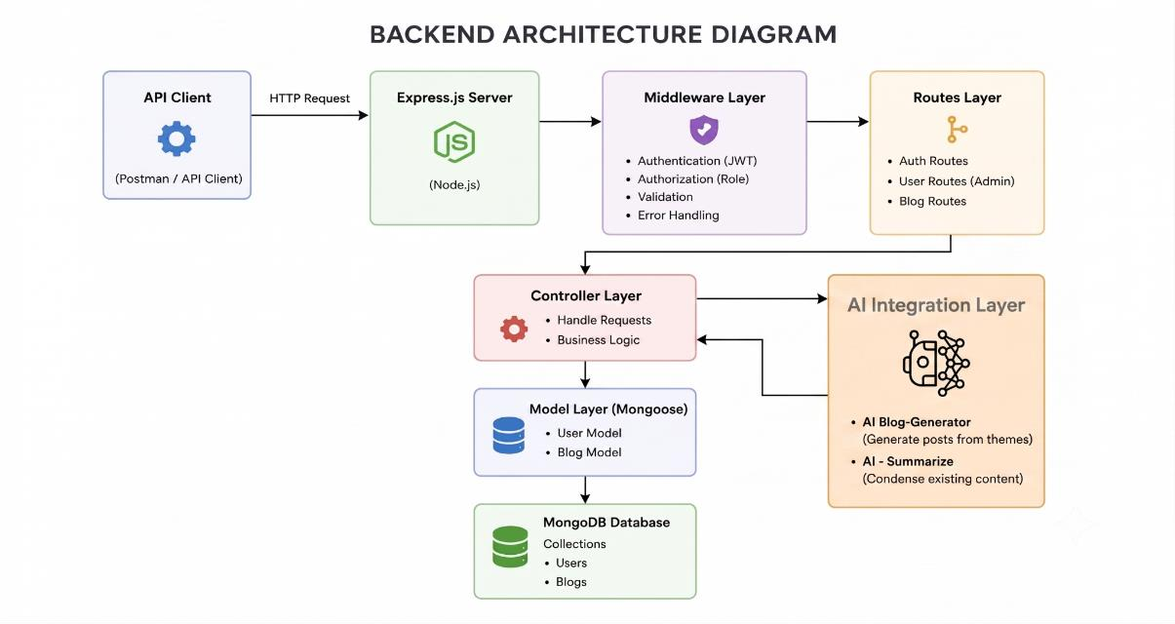

Architecture Components Explanation
- Client

The client sends requests to the backend. Examples:
  - Register

  - Login

  - Create blog

  - Generate AI blog

  - Summarize blog

- Express Server

Express handles HTTP requests and provides APIs.

- Authentication

JWT is used to authenticate users.

- Routes

Routes determine which operation should be performed.

- Models

MongoDB models define the structure of user and blog data.

- MongoDB

MongoDB stores:

  - User information

  - Blog information

- Gemini AI

Gemini provides AI functionality for:

  - Blog generation

  - Summarization

Database / ER Diagram Explanation:
AI BlogNest primarily contains two important
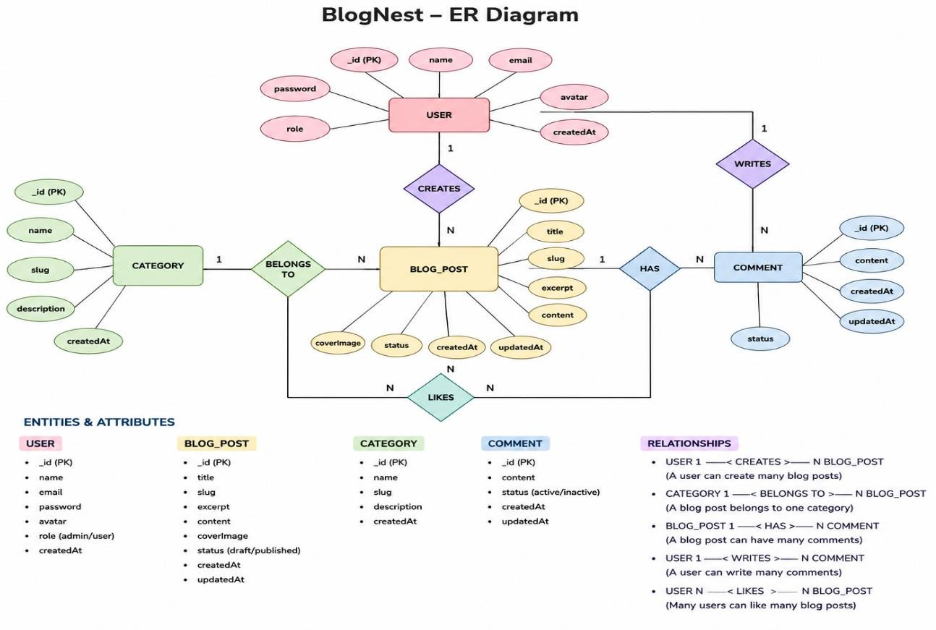

Relationship:
One user can create multiple blogs. Therefore:
USER 1 : M BLOG

User Entity

The User entity stores information about registered users.

Attributes

Attribute | Description
userId | Unique user identifier
name | User name
email | User email
password | Encrypted/hashed password
createdAt | Account creation date

Blog Entity
The Blog entity stores blog information. Attributes
Attribute | Description
blogId | Unique blog identifier
title | Blog title
content | Blog content
summary | AI-generated summary
authorId | User who created the blog
createdAt | Creation date
updatedAt | Last update date

Relationship Between Entities
The relationship between User and Blog is: One-to-Many relationship
One User

|

| creates

|

+ Blog 1

|

+ Blog 2

|

+ Blog 3

A single user can create many blogs.

A particular blog belongs to one author.

Key Features

User Features

  - Registration

  - Login

  - Secure authentication

Blog Features

  - Create blog

  - Read blog

  - Update blog

  - Delete blog

AI Features

  - Generate blog

  - Summarize blog

Security Features

  - Password hashing

  - JWT authentication

  - Protected routes

Database Features

  - User storage

  - Blog storage

  - User-blog relationship

Roles and Responsibilities

User

The user can:

  - Register

  - Login

  - Create blogs

  - View blogs

  - Generate AI content

  - Summarize content

User Flow:
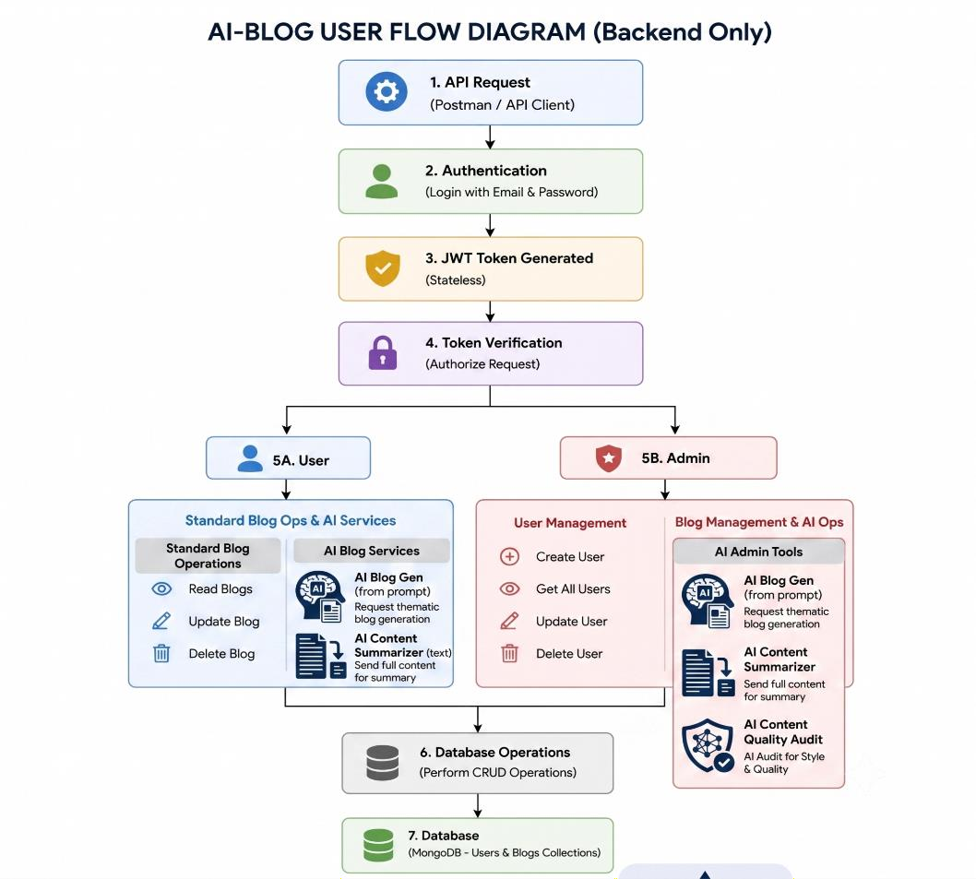

Technology Stack

Frontend

  - HTML

  - CSS

  - JavaScript

Backend

  - Node.js

  - Express.js

Database

  - MongoDB

  - Mongoose

Authentication

  - JSON Web Token

  - bcrypt

Artificial Intelligence Google Gemini API Testing
  - Thunder Client

Development Tool

  - Visual Studio Code

MVC Architecture Pattern
The system architecture structures its source configuration layers around the Model-View-Controller design pattern to completely decouple component.

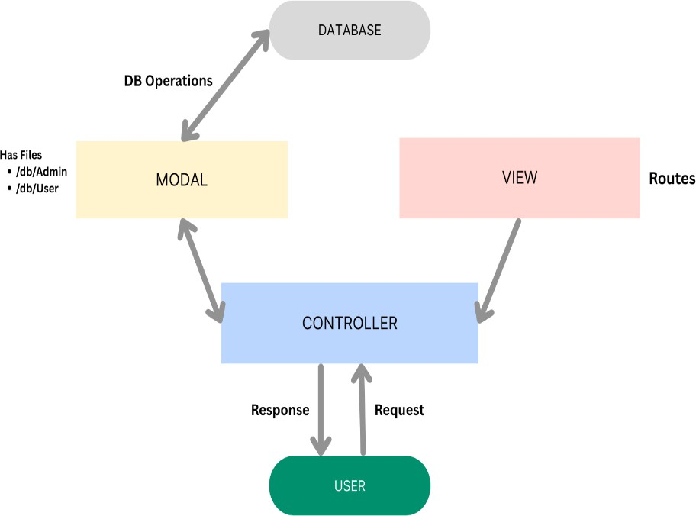

Project Folder Structure A suitable project structure is: AI-BlogNest/
│

├── controllers/

│ ├── authController.js

│ ├── blogController.js

│ └── aiController.js

│

├── middleware/

│ └── authMiddleware.js

│

├── models/

│ ├── User.js

│ └── Blog.js

│

├── routes/

│ ├── authRoutes.js

│ ├── blogRoutes.js

│ └── aiRoutes.js

│

├── config/

│ └── db.js

│

├── .env

├── .gitignore

├── app.js

├── server.js

├── package.json

└── README.md

Project Setup
First create the project folder:
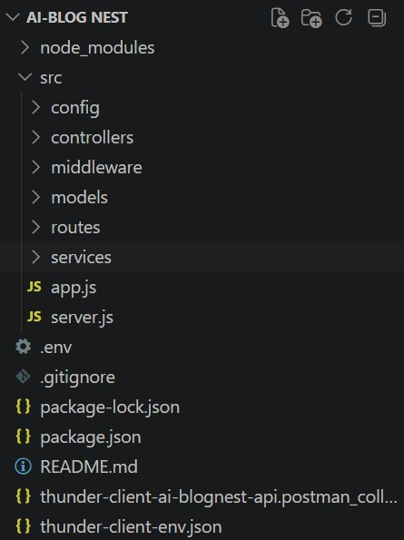

Server setup (npm init)
mkdir AI-BlogNest cd AI-BlogNest
Initialize Node.js:

npm init -y

npm init

The following command initializes a Node.js project:

npm init -y package.json

The package.json file contains:

- Project name

- Version

- Scripts

- Dependencies

- Project information

Package Installation
Install the required packages:

npm install express mongoose dotenv bcryptjs jsonwebtoken cors

For Gemini:
npm install @google/generative-ai For development:
npm install --save-dev nodemon

Important Packages

Package | Purpose
express | Backend server
mongoose | MongoDB connection
dotenv | Environment variables
bcryptjs | Password hashing
jsonwebtoken | Authentication
cors | Cross-origin requests

.env Configuration:
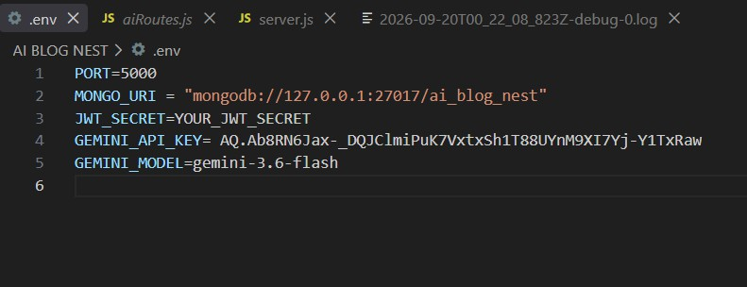

server.js Code :
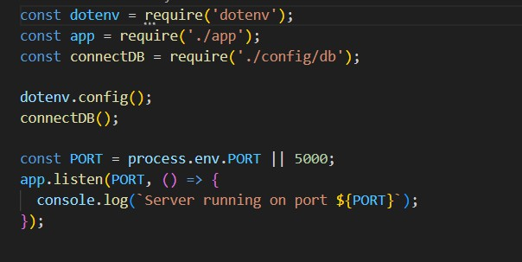

app.js Code:
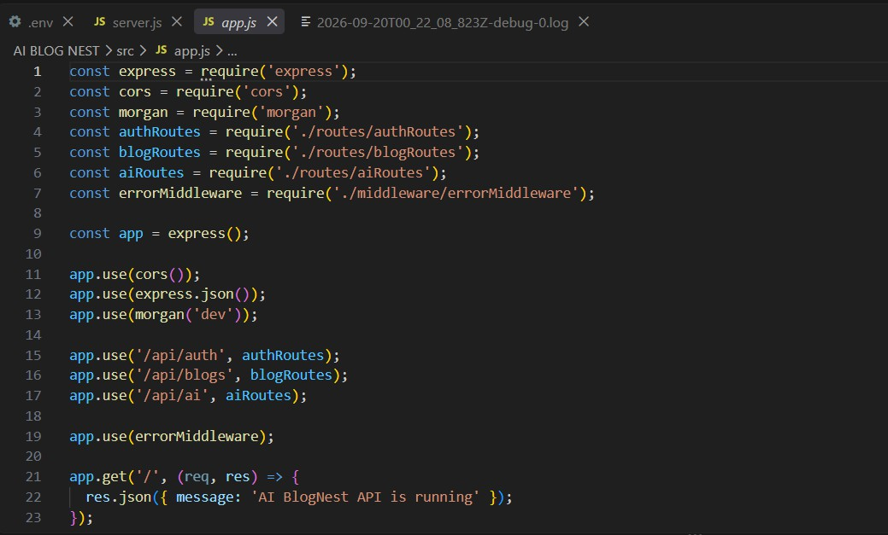

MongoDB Connection Code

config/db.js
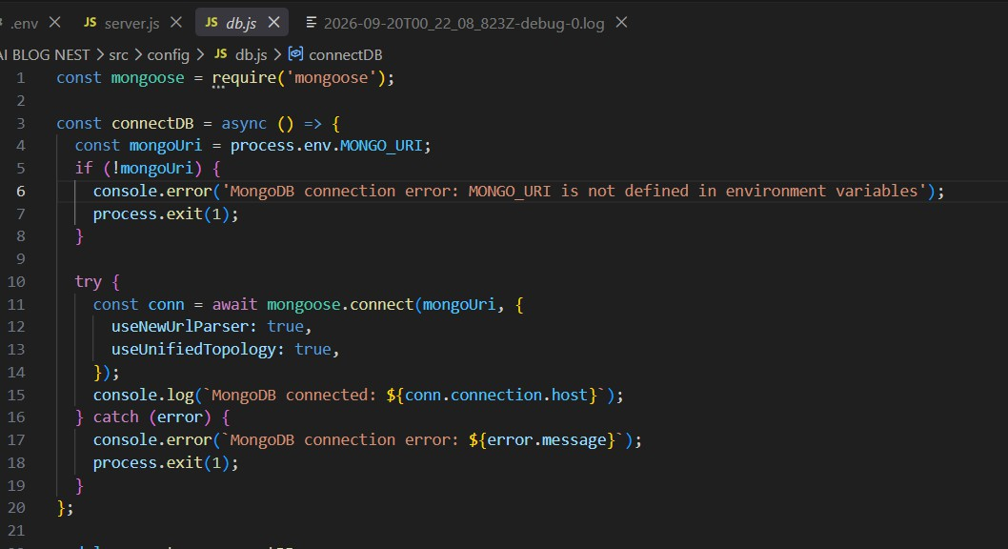
MongoDB Connected is displayed.

User Model Code :

models/User.js
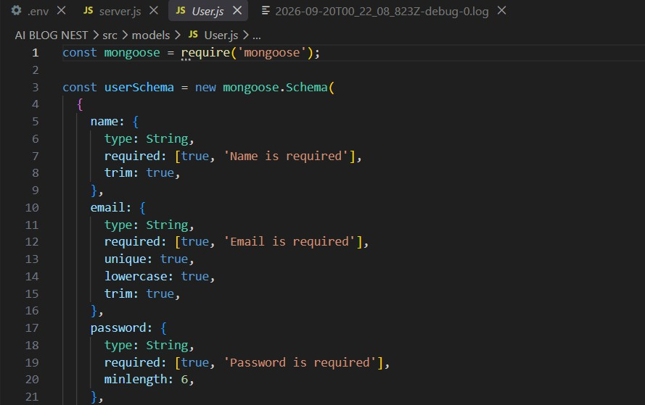

Blog Model Code

models/Blog.js
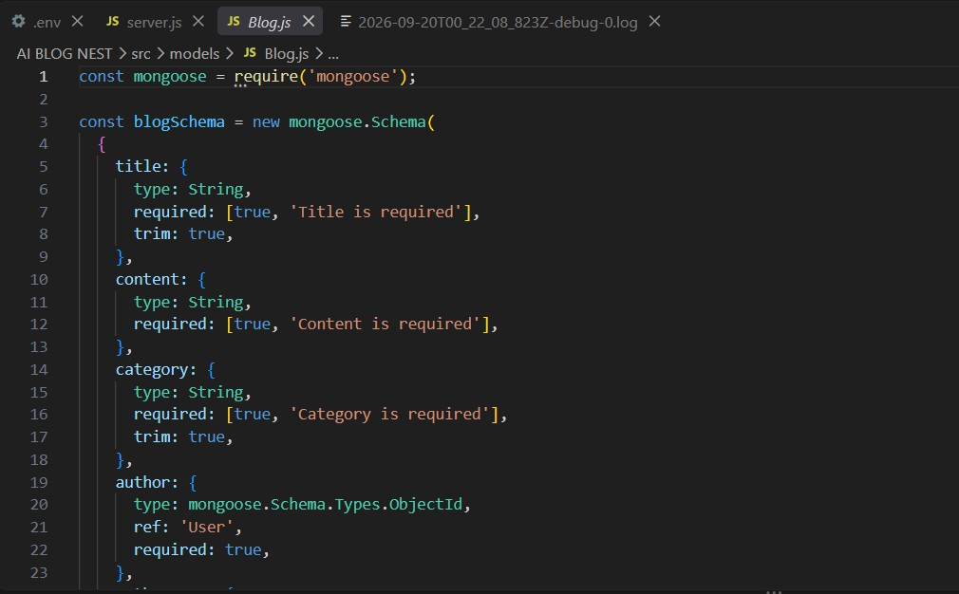

JWT Code

JWT stands for JSON Web Token.
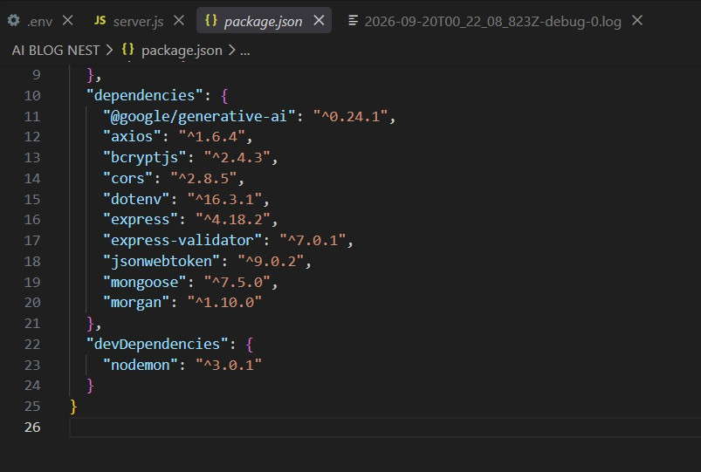

Blog CRUD Code
CRUD means:

- C – Create

- R – Read

- U – Update

- D – Delete

AI Gemini Configuration

Gemini is used to provide AI-powered functionality.

Middleware:

Authentication Middleware
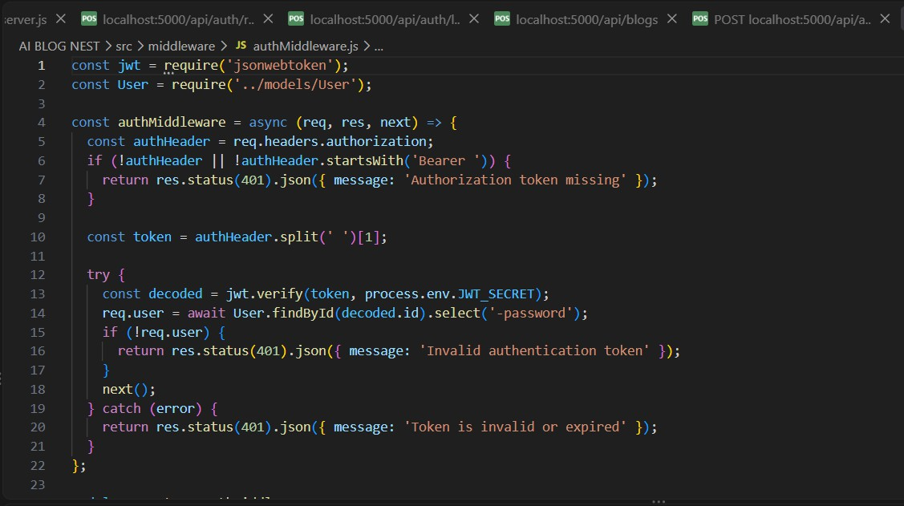

The middleware:

- Gets the JWT.

- Verifies the JWT.

- Identifies the user.

- Allows access to protected routes.

Project Executions:
· Install Postman or ThunderClient (VS Code extension). Start the backend server:
“npm start”

API Testing :
Routes

Authentication Routes

User Registration :
POST /api/auth/register
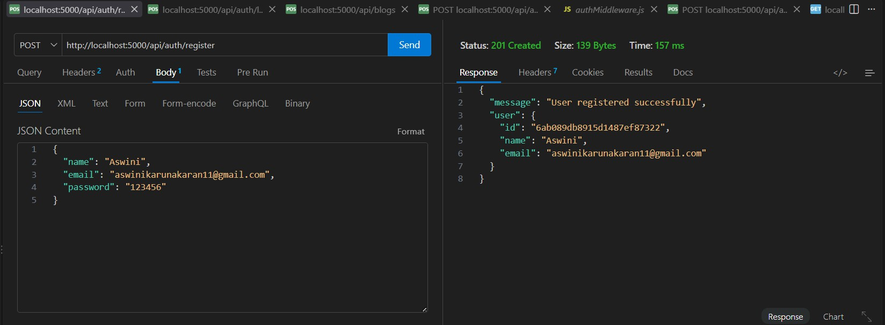

User Login:

POST /api/auth/login

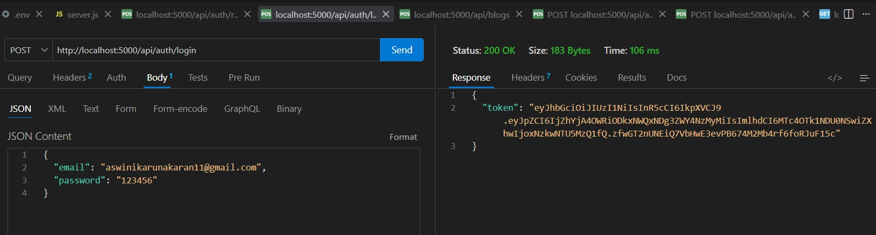

Create Blogs :
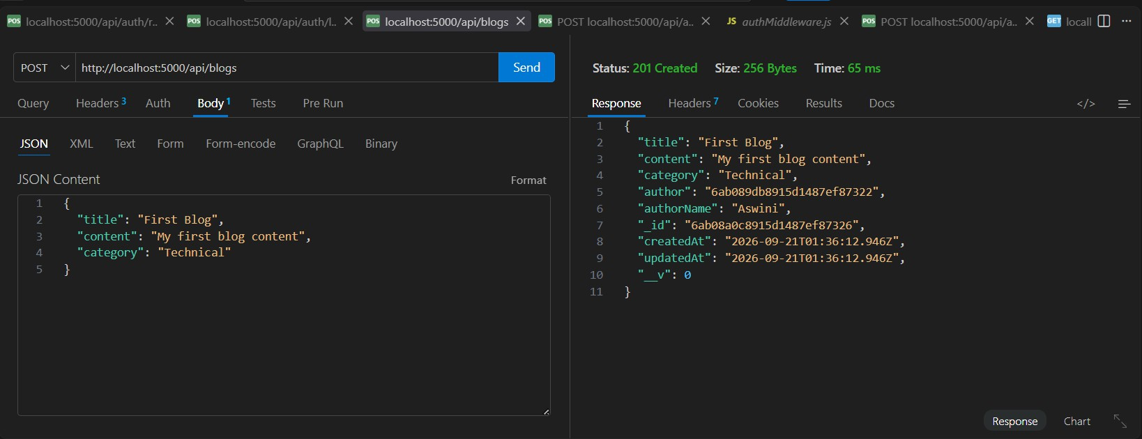

Fetch Blogs :
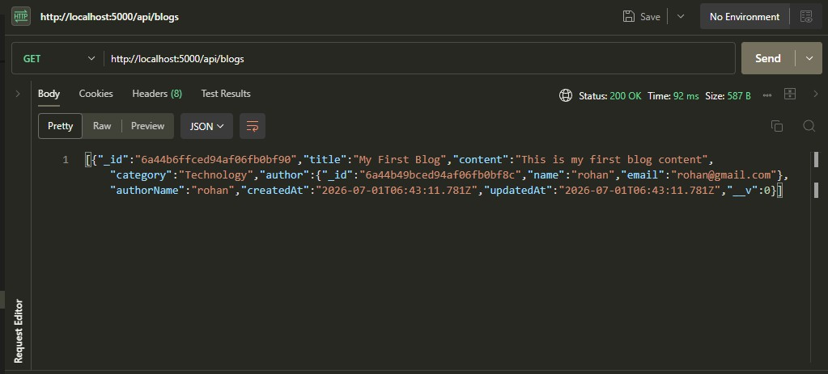

Generate AI blogs :
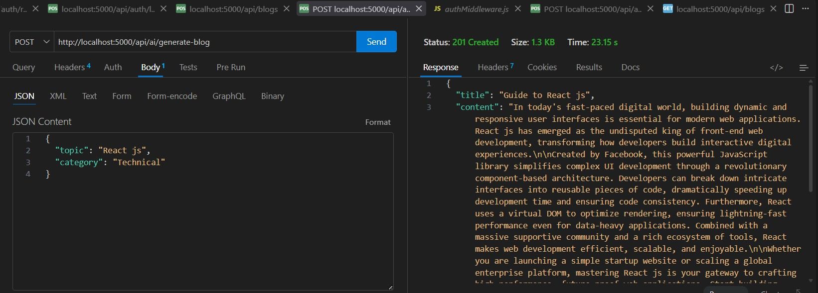

Summarize Blogs :
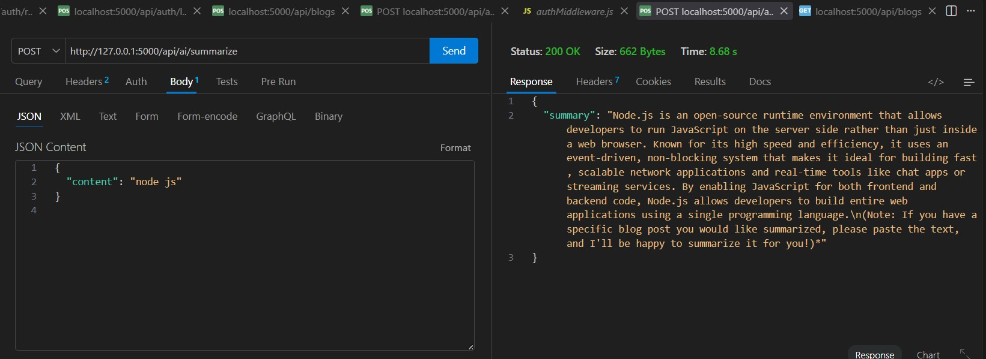

Get blogs:
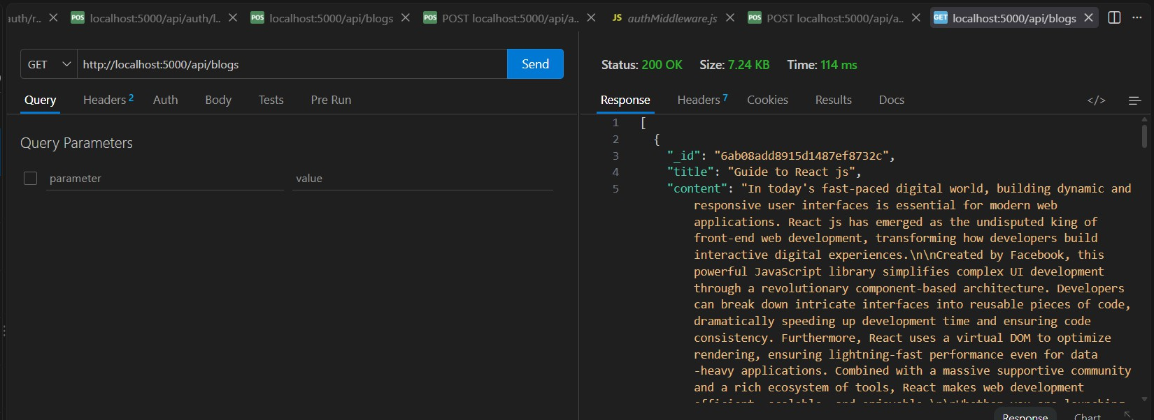

Complete API Endpoint Table:

Method | Endpoint | Purpose | Authentication
POST | /api/auth/register | Register user | No
POST | /api/auth/login | Login user | No
POST | /api/blogs | Create blog | Yes
GET | /api/blogs/:id | Get one blog | No/Yes
POST | /api/ai/generate | Generate blog | Yes
POST | /api/ai/summarize | Summarize blog | Yes

Expected Outputs:

Registration
User registered successfully

Login
Login successful

JWT token generated

Blog Creation
Blog created successfully

Blog Retrieval
Blogs retrieved successfully

AI Generation
AI-generated blog content displayed

AI Summarization
Summary generated successfully

Advantages
- Secure user authentication.

- Easy blog management.

- MongoDB provides flexible data storage.

- REST APIs make the system scalable.

- JWT provides token-based authentication.

Conclusion
AI BlogNest is an AI-powered blog management system that combines traditional blogging functionality with Artificial Intelligence.
The system provides essential features such as user registration, authentication, blog creation, blog management, and secure database storage. The integration of Gemini AI provides advanced features such as automatic blog generation and summarization.
The project demonstrates the practical implementation of:

  - Node.js

  - Express.js

  - MongoDB

  - Mongoose

  - JWT

  - REST APIs

  - Google Gemini AI

